Attachment A

Direct Charge Portal User Guide

Table of Contents

Managing Web Portal Users 2

Create a New Portal User 2

Deactivate a Portal User 2

Managing Agencies 3

Request Access to an Agency 3

Create a New Subagency on the Portal 6

Update a Subagency's Maximum Charge Amount 7

Loading Annual Direct Charges 9

Upload Annual Direct Charges 9

Possible Error Messages 11

Modify Uploaded Direct Charges 12

Certify Annual Direct Charges 12

Upload Direct Charge Uploads After Certification Prior to the Annual Deadline 14

Upload Direct Charge Uploads After the Annual Deadline 14

View Direct Charge Reports 14

Electronic Data Specifications for Special Assessments 15

Requirements 15

Example File 16

**Direct Charge Portal User Guide**

# **Managing Web Portal Users**

## **Create a New Portal User**

1. Visit <https://www.sbcountyatc.gov/tax-services/direct-charges>.
2. Click "Log In" at the top right of the screen.
3. First time logging in:
   * **Option 1**: Create an account using email and password by clicking "Sign Up".
     + Enter email, password, first name, last name and click "Register".
     + After this, you may be prompted to also enter more information (phone number, address, etc). Fill out this information if prompted and submit.
   * Option 2: Use Google or Microsoft
     + When prompted, enter the email address and password as part of this signup.
     + After this, you may be prompted to also enter more information (phone number, address, etc). Fill out this information if prompted and submit.
4. Subsequent logins:
   * Option 1: Enter email and password and click "Sign In".
   * Option 2: Use Google or Microsoft to log in.
5. You will be redirected back to <https://www.sbcountyatc.gov/tax-services/direct-charges>.

## **Deactivate a Portal User**

1. Navigate to the main page of the Direct Charge Portal.
2. Click the three dots in the upper right corner and select “Deactivate Account” from the drop down.

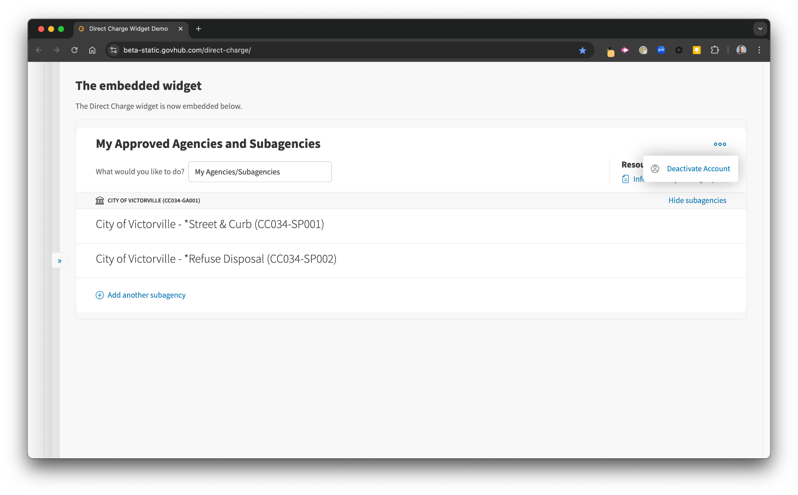

1. Confirm by clicking “Yes, Deactivate Account.”
   1. Clicking “Cancel” will take you back to the main screen without changing any access.

# **Managing Agencies**

## **Request Access to an Agency**

1. Once the county has received the signed agreement form for the jurisdiction, you can request access to an agency.
2. From "What would you like to do?" select “My Agencies/Subagencies”.
3. Click "Add an agency or subagency".
   1. The first time you log in to the portal, you will not yet have access to any subagencies.
   2. If you already have access to subagencies, this link will say “Add another subagency”.

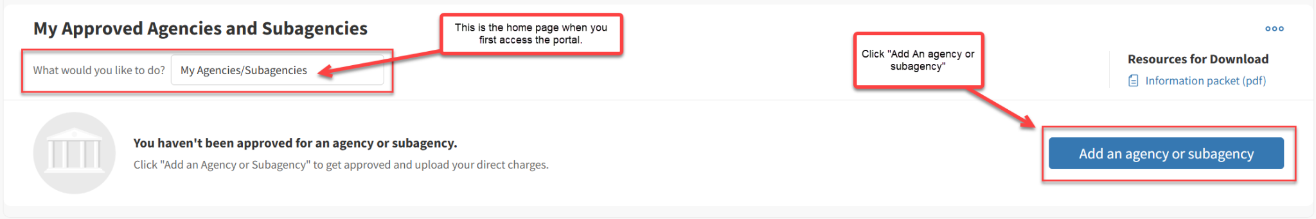

1. Click "Request access to existing agency/subagency".

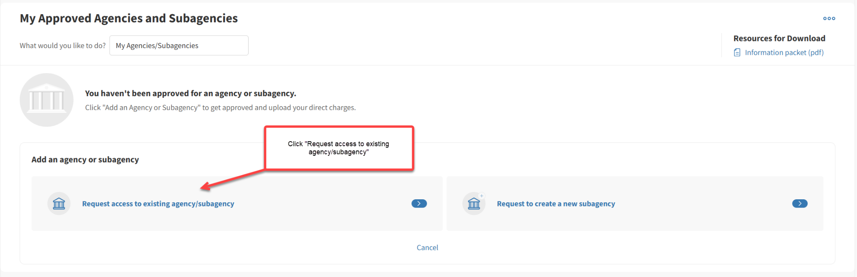

1. Choose an agency from the dropdown menu.

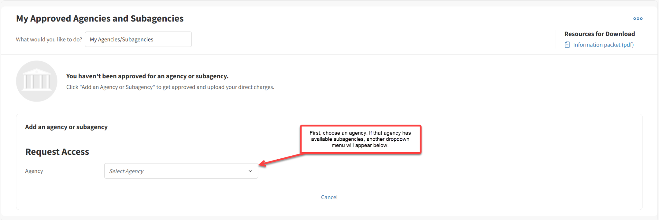

1. Select one (or multiple) of the available subagencies to request.
   1. Add a note if desired. This is included in the information the County will review.
   2. Click "Submit".

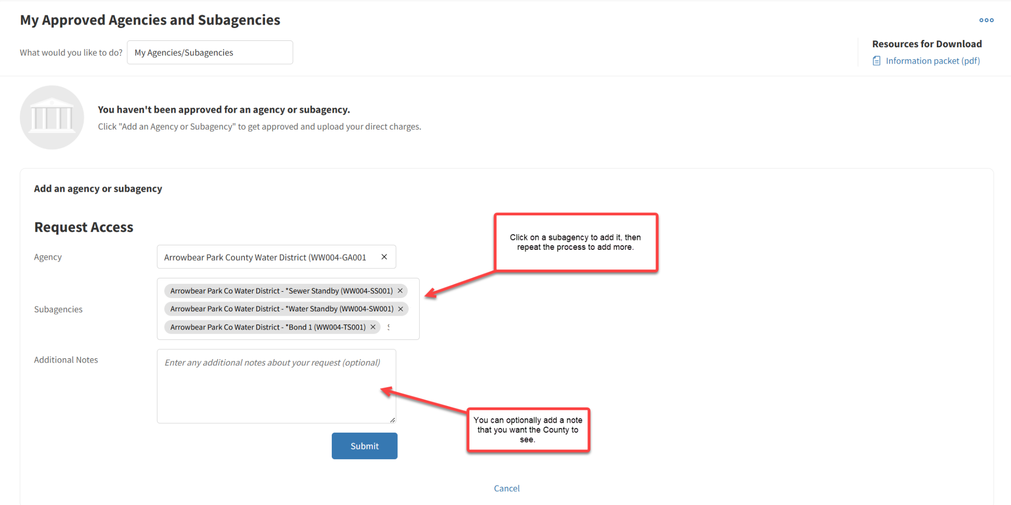

1. Click "Add another subagency" and complete the request process as many times as needed to access all the subagencies needed.

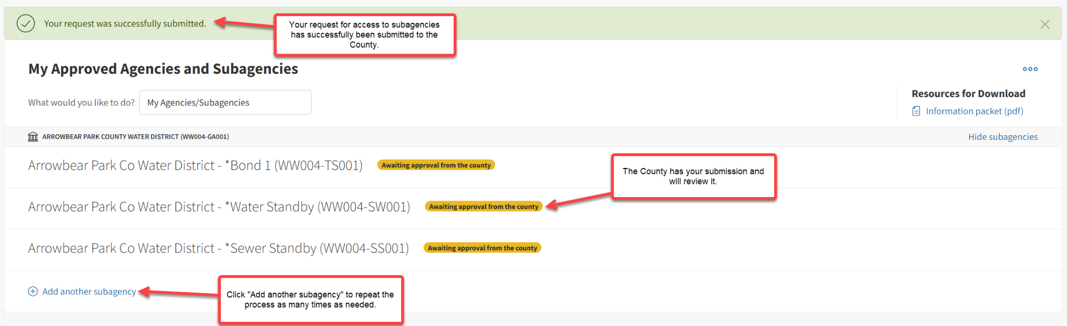

1. **Note:** The submitted requests will be received by the Property Tax Division. That division will set the appropriate permission level for each request. Permission levels include:
   1. Read/Write - allows the user to upload annual direct charges
   2. Read-Only - allows the user access to Portal reports
   3. No Access - user is denied access for the agency
2. You will receive an email when the County has responded to your request.

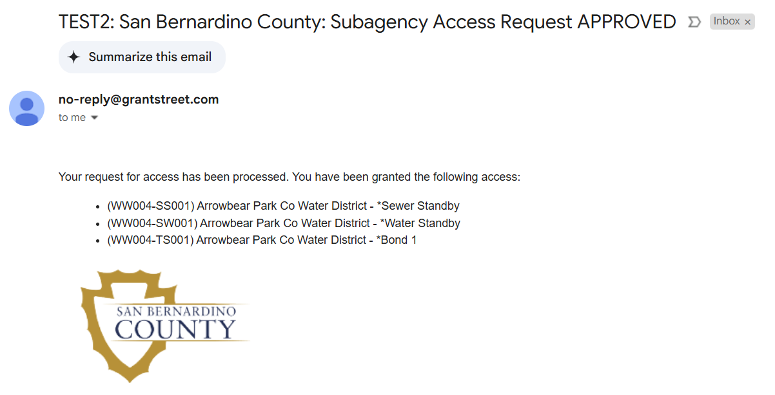

1. Now you can see your newly approved agencies and subagencies.

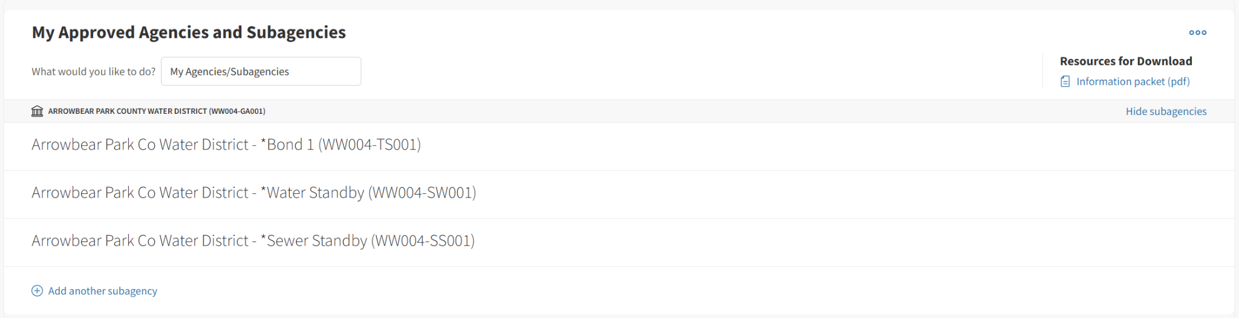

## **Create a New Subagency on the Portal**

1. From "What would you like to do?" select “My Agencies/Subagencies”.
2. Click "Add another subagency".

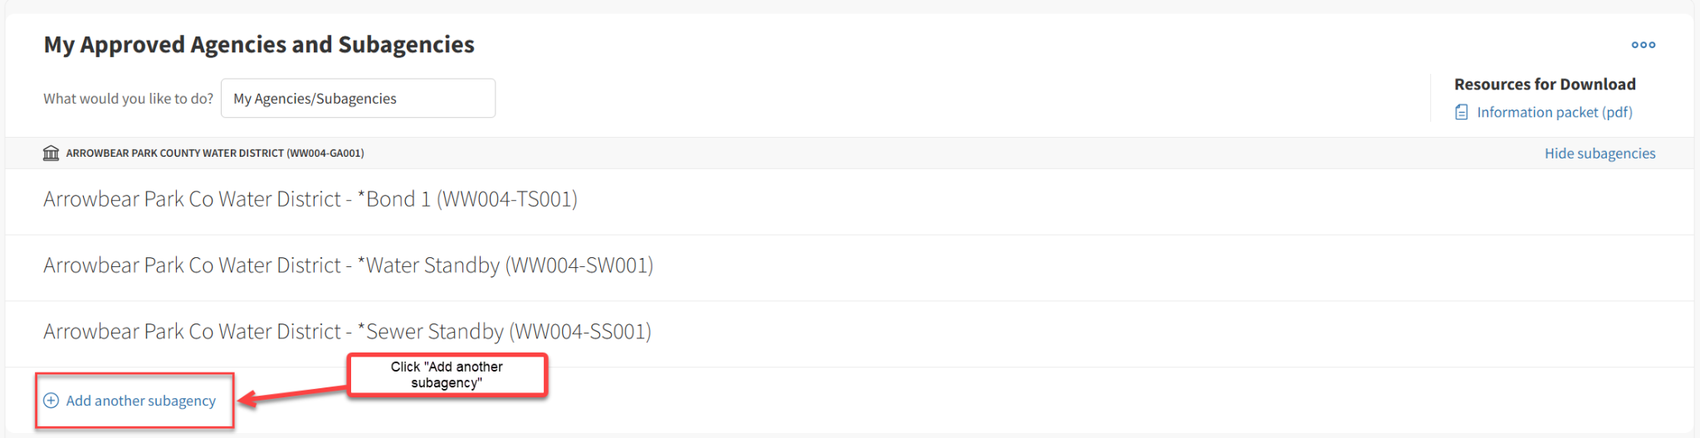

1. Click "Request to create a new subagency".

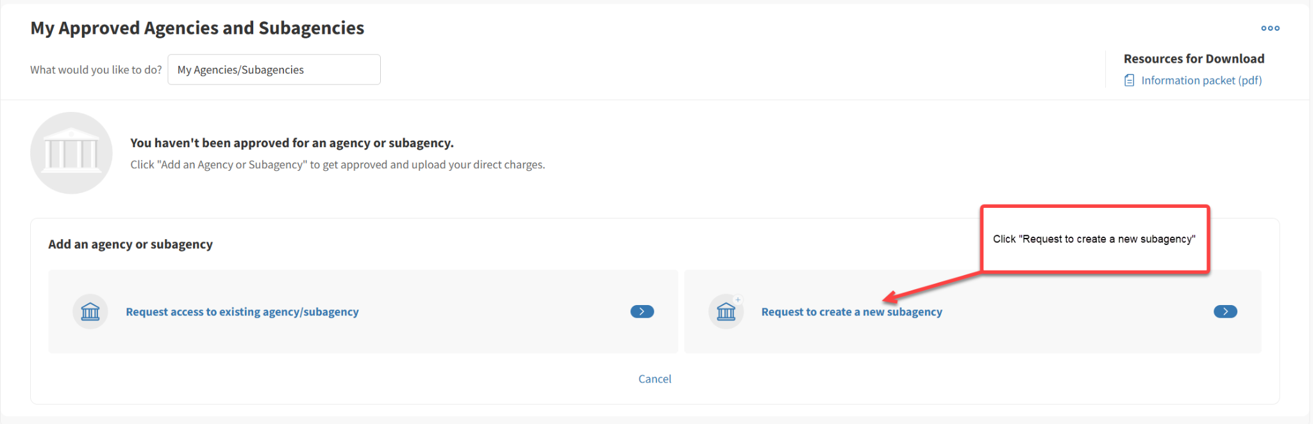

1. You will be presented with a form; complete all of the required fields including:
   1. Subagency Name and Address information
   2. Maximum Charge Amount (if applicable)
   3. Subagency Contact information
2. Upload the required documentation.
   1. **ACH information should not be uploaded using the portal.**
   2. Include items such as the resolution authorizing the charge.
3. Add a note if desired. This is included in the information the County will review.
4. Submit the request for a new subagency.
5. The County will be notified of the new subagency request. You will receive an email stating that your submission has been received. TaxSys will not accept Direct Charges on a subagency prior to County approval.

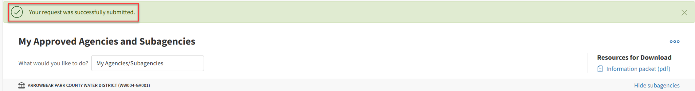

# 

1. Once your new subagency request has been approved, you will receive an email.

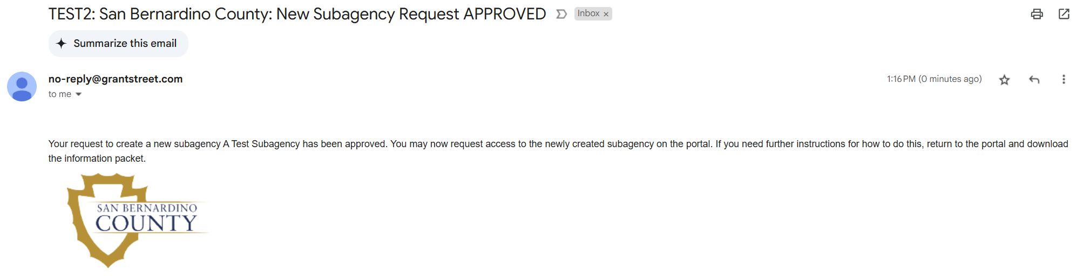

1. **Note: Now you must repeat the steps in “Request Access to an Agency” to get access to your newly created subagency. Until you do this, you will not see your newly created subagency under “My Approved Agencies and Subagencies.”**

## **Update a Subagency's Maximum Charge Amount**

1. From "What would you like to do?" select “Upload/Manage Upcoming Roll”.
2. Locate the appropriate subagency.
3. Click the existing "Max Charge" or "No max charge".
   1. **Note: The Max Charge is the maximum amount of a charge allowed per parcel.**

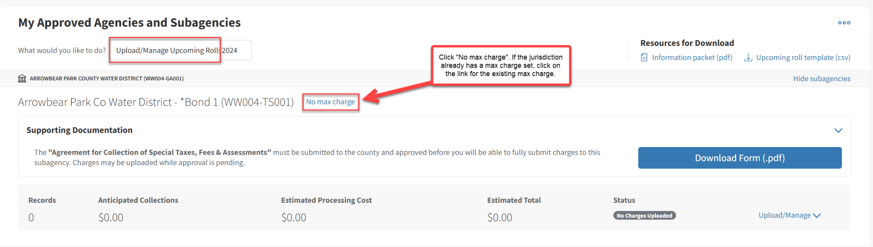

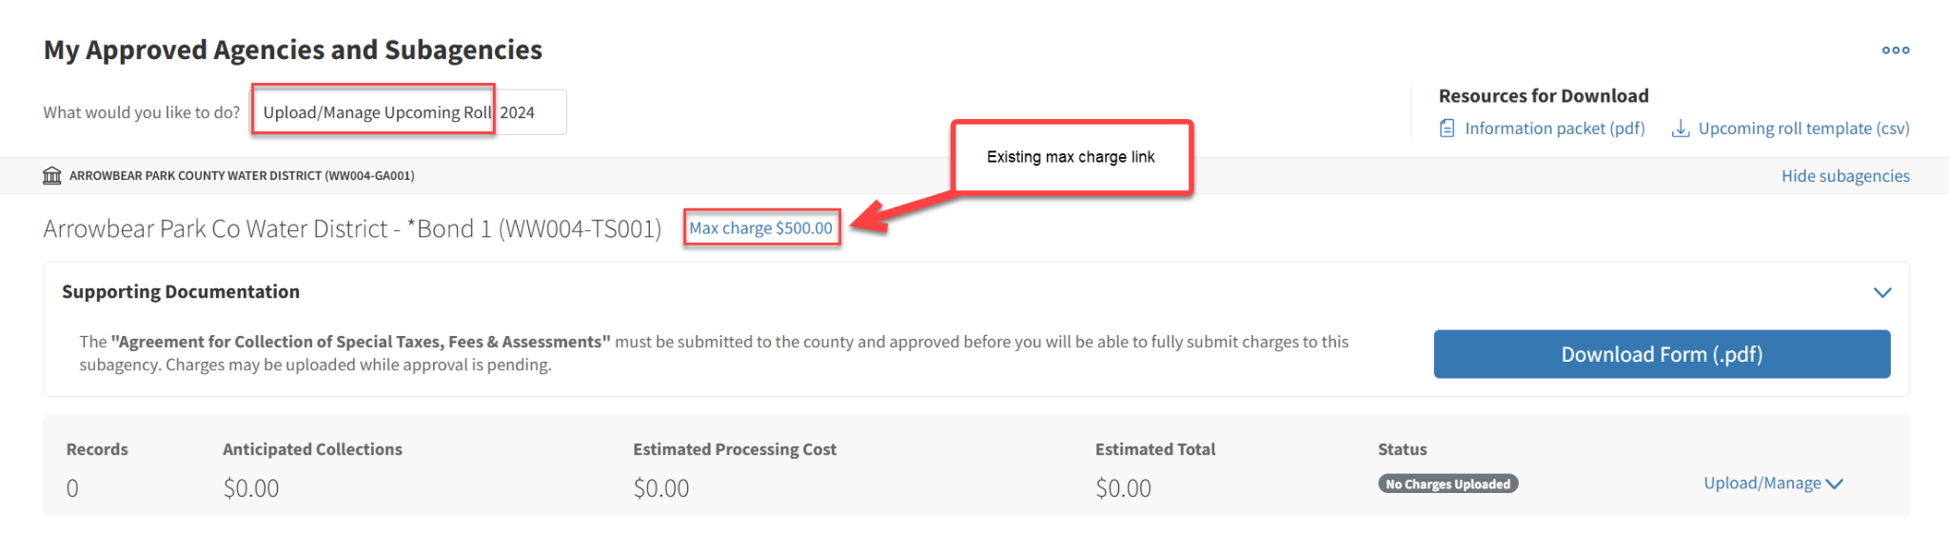

1. Select "Yes".

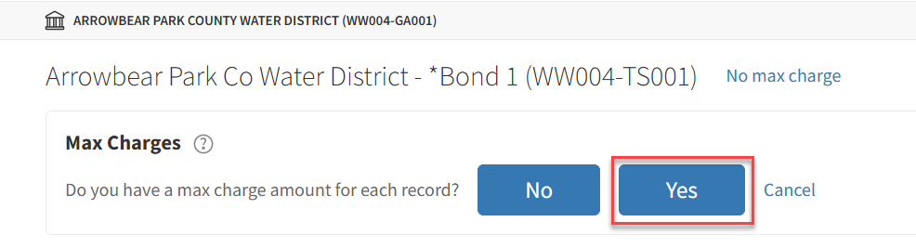

1. Enter a dollar amount and click "Submit".

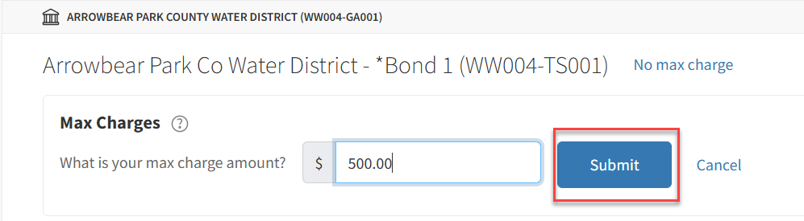

# **Loading Annual Direct Charges**

## **Upload Annual Direct Charges**

1. From "What would you like to do?" select “Upload/Manage Upcoming Roll”.
2. Find the appropriate subagency.
3. Click "Upload/Manage".

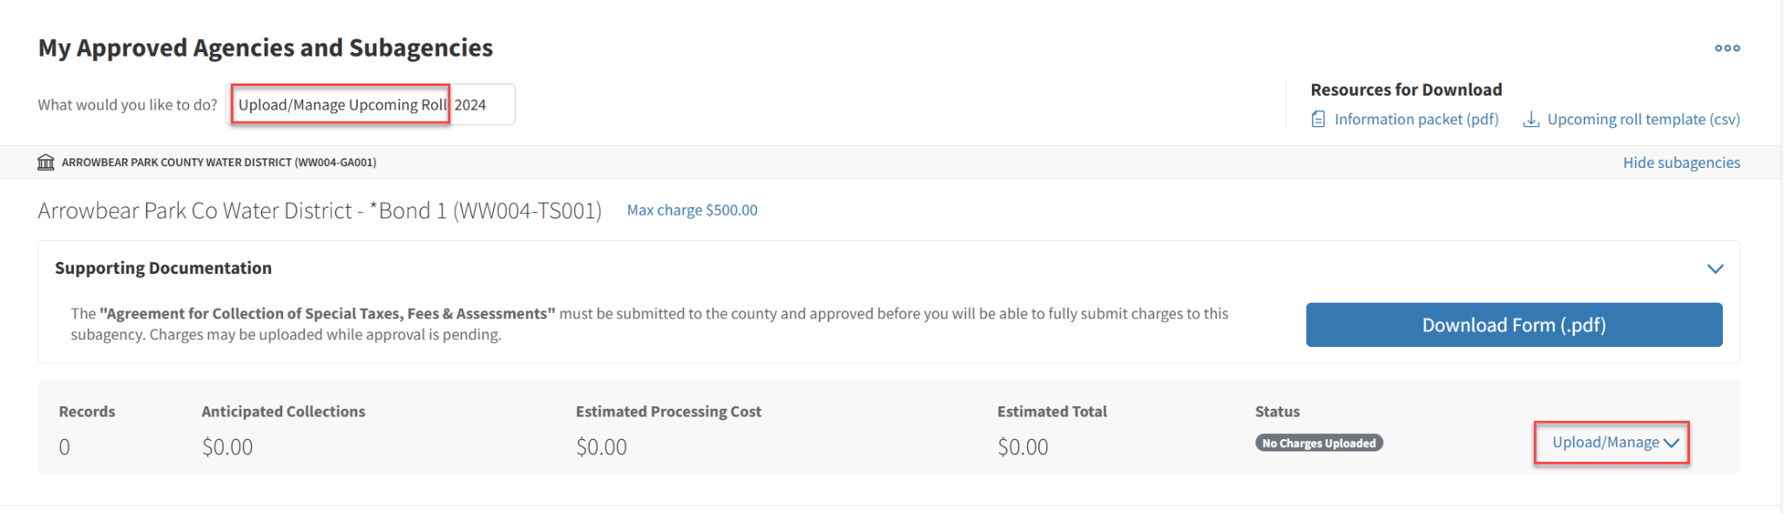

1. Upload the Direct Charge file.
   1. See the *Electronic Data Specifications for Special Assessments* section for help creating the data file.
   2. You cannot upload records for multiple subagencies in a single file.

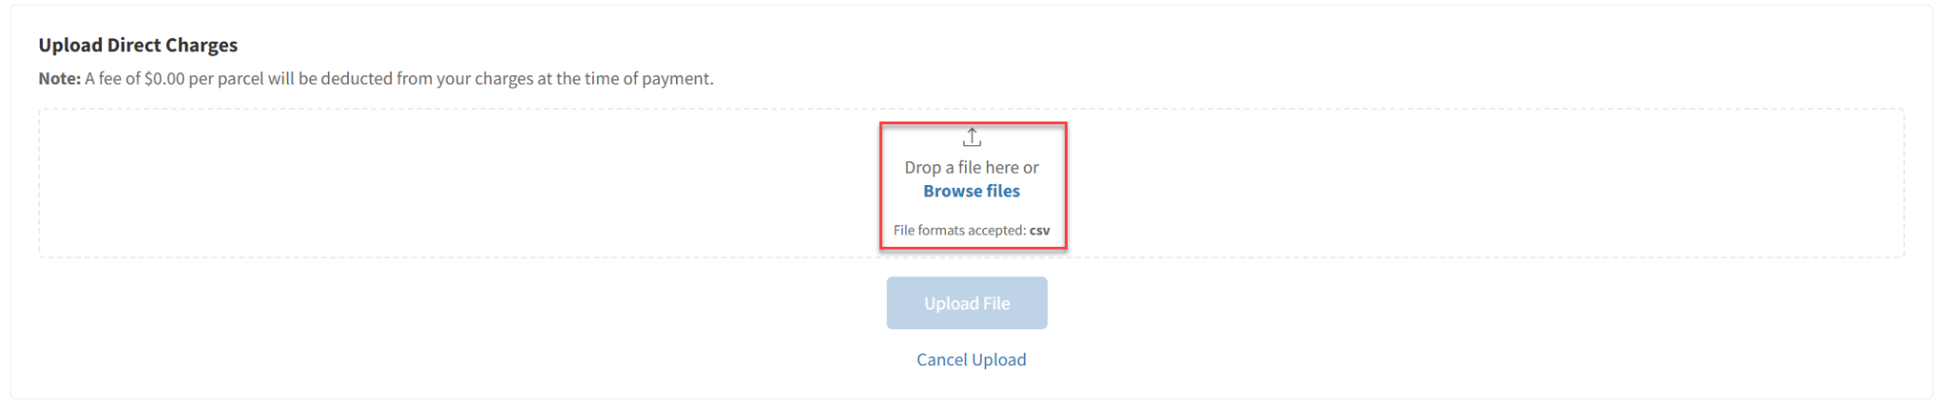

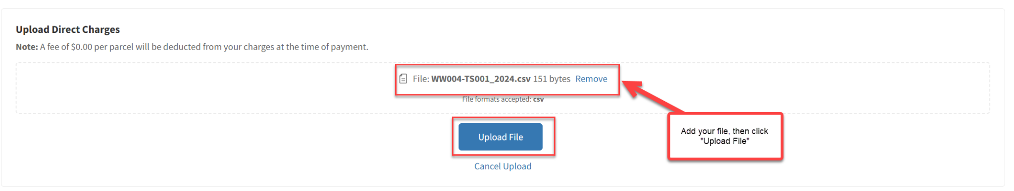

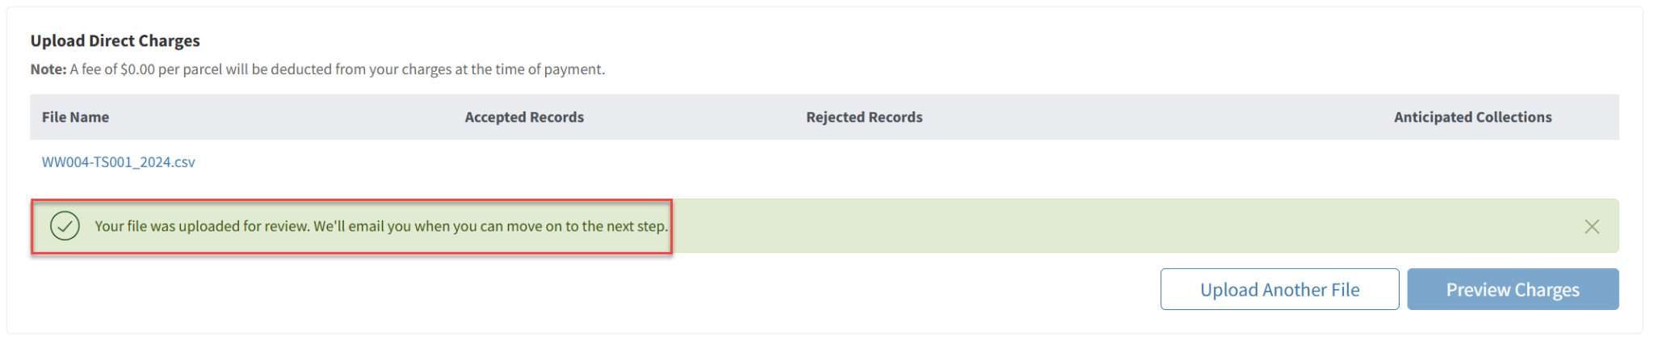

1. The system will validate and load the file. You will receive an email after the load completes.

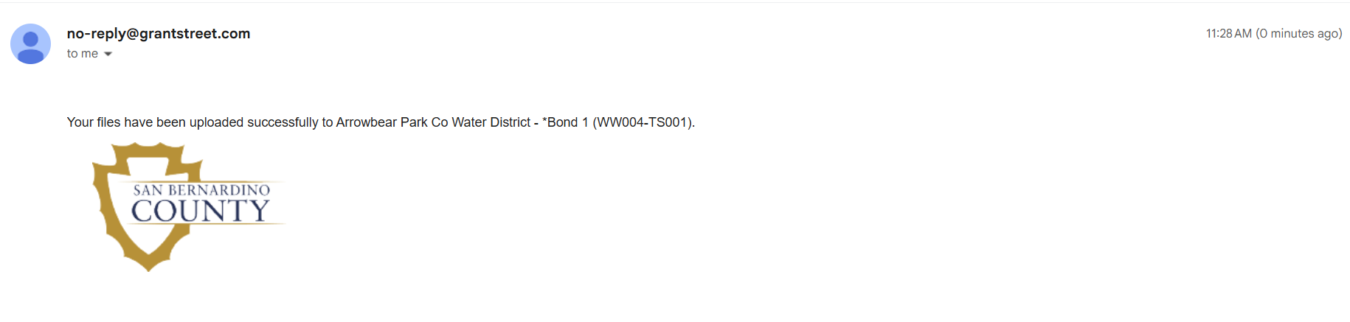

1. Once complete, go to “Upload/Manage Upcoming Roll”. There you will see a summary report of the accepted and rejected records. You can also view and download detailed reports.
2. Review the results and determine whether the results should be certified or modified.
   1. If there is an error, review the Error Message to determine next steps and make necessary modifications.
   2. If no errors are present, certify the Direct Charges.

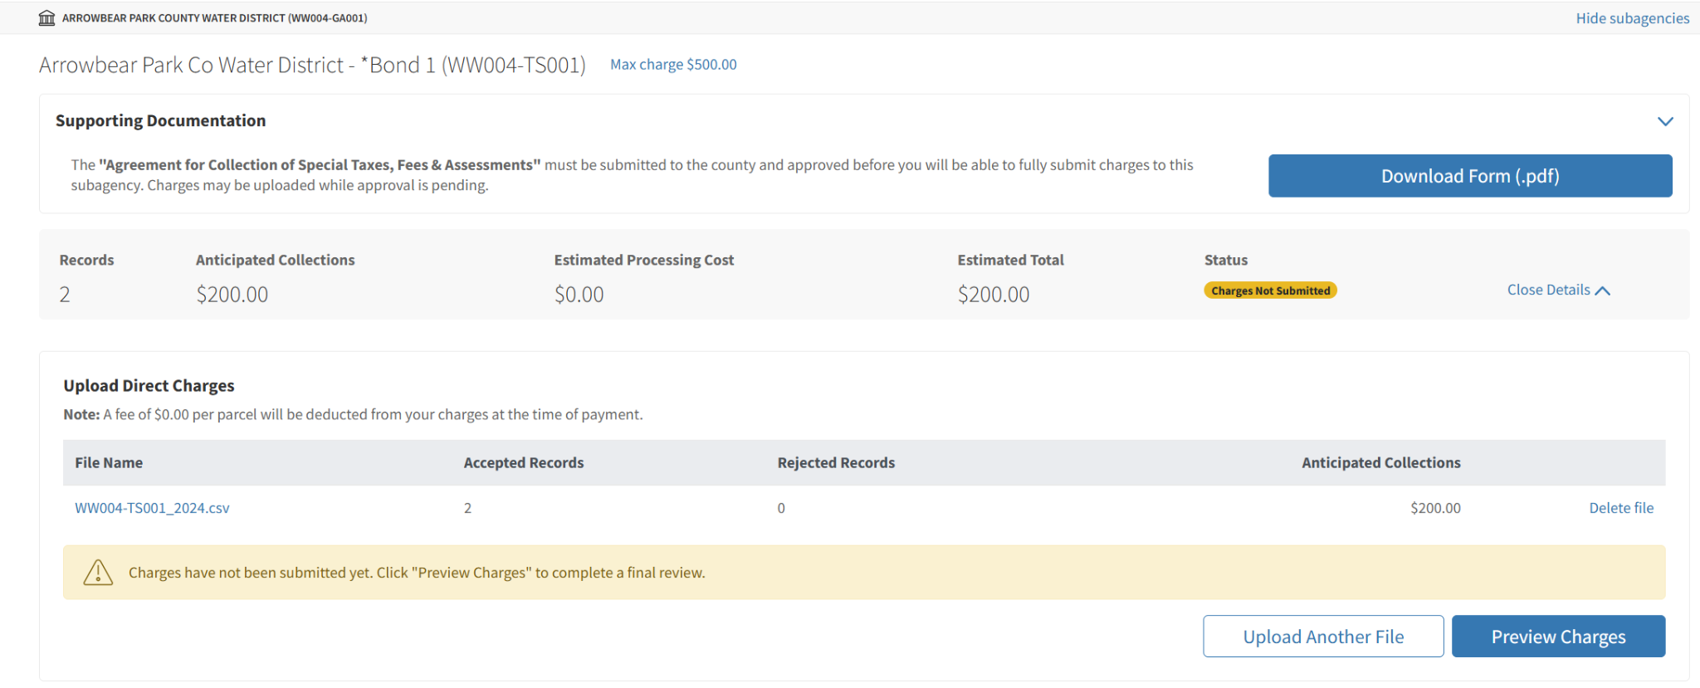

## **Possible Error Messages**

1. After uploading direct charges on the portal, the system will validate and load the file.
2. Once complete, go to “Upload/Manage Upcoming Roll”. There you will see a summary report of the accepted and rejected records.
3. You can also view and download detailed reports.
   1. Click the File Name to view a report of all loaded data.
4. Click the ‘Details’ link under Rejected Records to see the reason for the errors.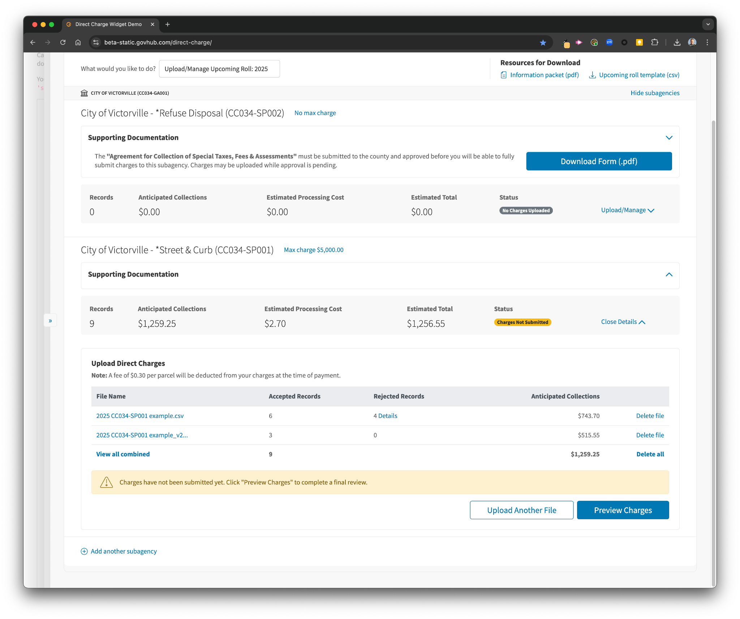
5. There are several different issues that could cause the direct charge file to error, including (but not limited to):
   1. Parcel number does not exist on the preliminary roll
   2. Parcel is tax exempt
   3. File includes duplicate charges
   4. Invalid jurisdiction code
   5. Max charge rate exceeded
6. If you encounter any of these issues, continue on to ‘Modify Uploaded Direct Charges’.

## **Modify Uploaded Direct Charges**

1. From "What would you like to do?" select “Upload/Manage Upcoming Roll”.
2. Find the appropriate subagency.
3. Click "Upload/Manage."
   1. Review the existing uploaded files and accepted/rejected records. You can click into more detailed reports for additional information.
   2. If you need to adjust or remove any records, you will need to delete the file that record came from by clicking "Delete file."
   3. In the event the user intends to upload a new file for all the records, the user should first delete all existing files by clicking "Delete all."
4. If you decide to add records, upload additional files as described in *Upload Annual Direct Charges*.



## **Certify Annual Direct Charges**

1. From "What would you like to do?" select “Upload/Manage Upcoming Roll”.
2. Find the appropriate subagency.
3. Click "Upload/Manage" and then "Preview Charges".

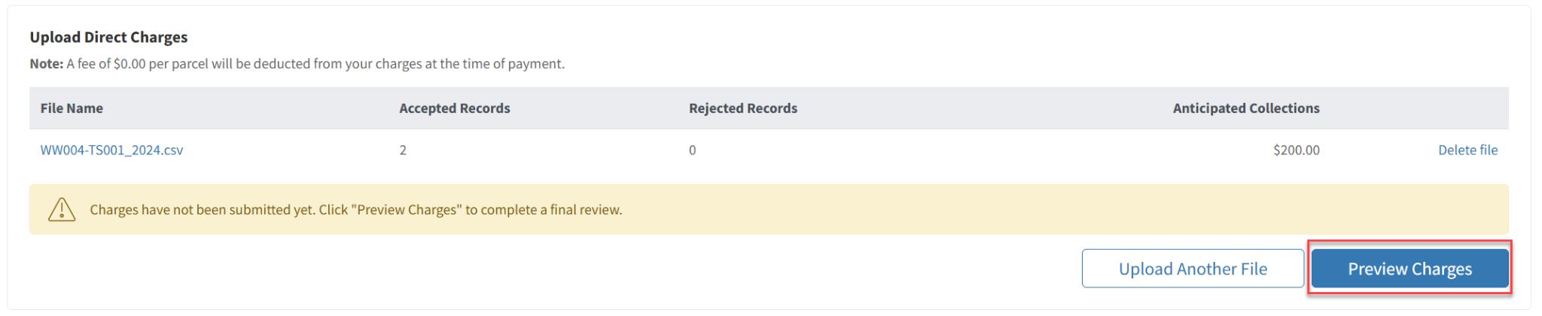

1. Review the parcel count and total charge amount of accepted charges for that subagency.
2. Review and reconcile your submission before proceeding to the next step.
3. Click "Finalize and Submit".
   1. ***Note:*** *After this point, you will be unable to make any additional changes on the portal for that roll year. Verify that all required signed agreements are sent in before finalizing; the county will be unable to process your submission without them.*

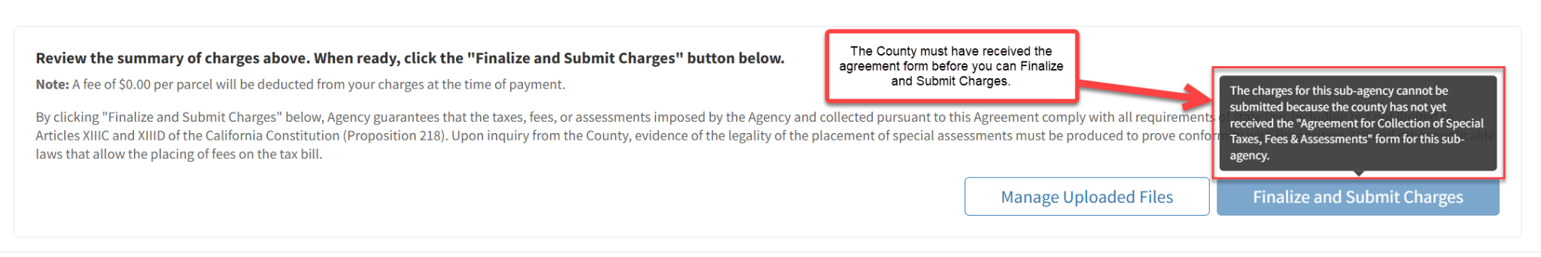

1. Enter the number of records and anticipated collection amount.

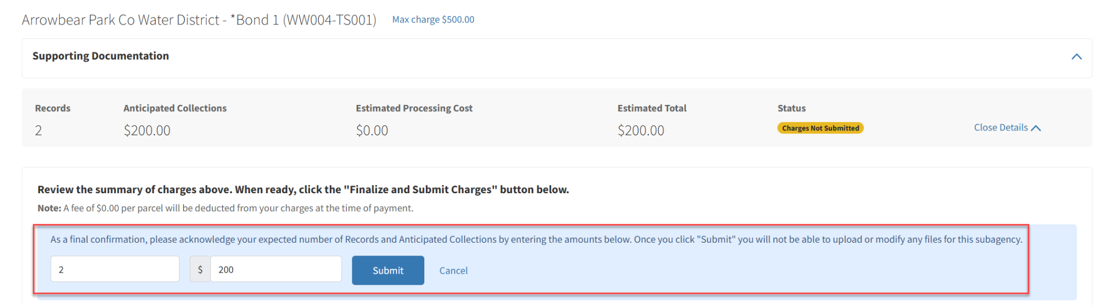

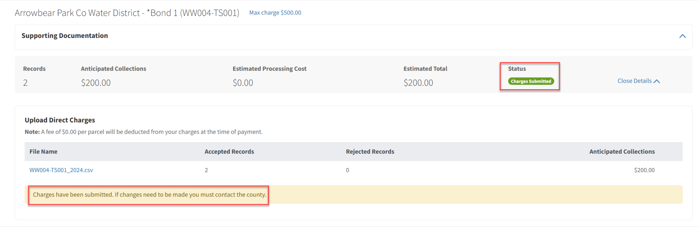

## **Upload Direct Charge Uploads After Certification Prior to the Annual Deadline**

Contact the Property Tax Division to make changes to the annual direct charge load after you’ve certified the load.

## **Upload Direct Charge Uploads After the Annual Deadline**

Contact the Property Tax Division to load direct charges after the annual deadline.

## **View Direct Charge Reports**

1. From "What would you like to do?" select "Run Reports".

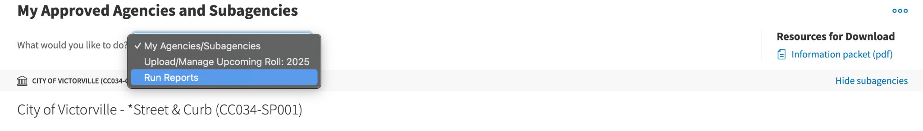

1. Choose the Roll Manager category to see reports of direct charge information prior to the county creating the new year's bills. Reports available in this category:
   1. DCW - Direct Charge Load Data: A report of loaded direct charges.
   2. DCW - Direct Charge File Errors: A report listing errors from file uploads.
   3. DCW - File Format with Records: A report containing the same columns as required by the file upload process that can be used to create an upload file.

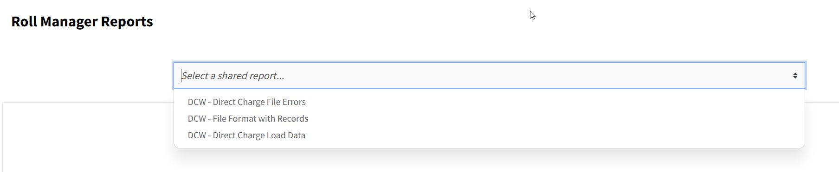

1. Choose the Property Tax category to see reports of direct charges that appear on bills generated by the county. Reports available in this category:
   1. DCW - Direct Charge Amounts Levied: A report of direct charge amounts billed and their balance status (paid or unpaid). Also includes distribution date.
   2. DCW - Direct Charge Totals per Levy: A report showing total direct charge amounts per levy.

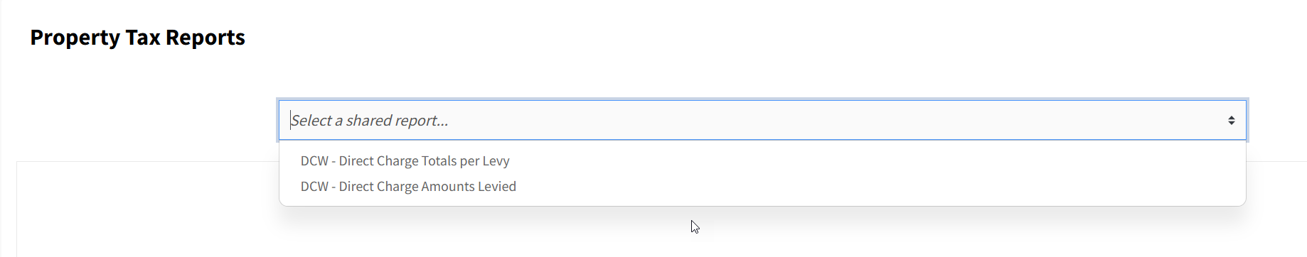

1. Once viewing the selected report, click one of the format icons next to “Download” at the top right of your screen to download the report.

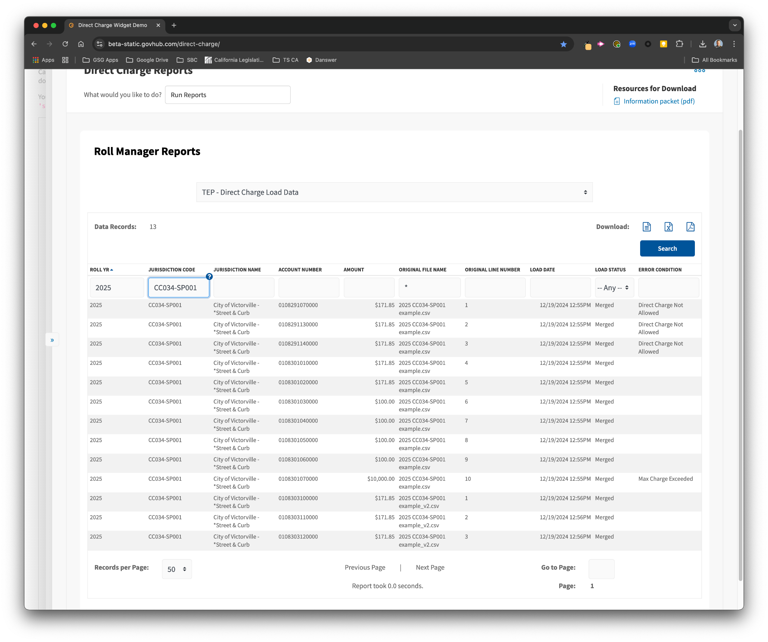

# **Electronic Data Specifications for Special Assessments**

Annual direct charges must be uploaded using a comma-separated value (CSV) file format.

## **Requirements**

* Each file must be limited to a single subagency (agency account) code. You may upload multiple files per subagency.
* Fields must be comma-separated.
* Each levy record must consist of the following fields, in order:
  + **Parcel Number** (13 digits with no dashes or spaces)
  + **Assessment Year** (Numeric, 4 digits)
  + **Agency Account Code** (10 characters and hyphen, ex. AA099-SP001)
  + **Amount** (round to two (2) Decimal places) [1]
* A header row is optional. If included, it should contain:
  + parcel_number, assessment_year, code, amount

## **Example File**

parcel_number, assessment_year, code, amount

0108303100000,2025,CC034-SP001,171.84

0108303110000,2025,CC034-SP001,171.84

0108303120000,2025,CC034-SP001,171.84

1. *Revised June 18, 2025: Updated the “****Amount”*** *from (decimal, even cents) to (rounded to two (2) decimal places).*